**Project:**

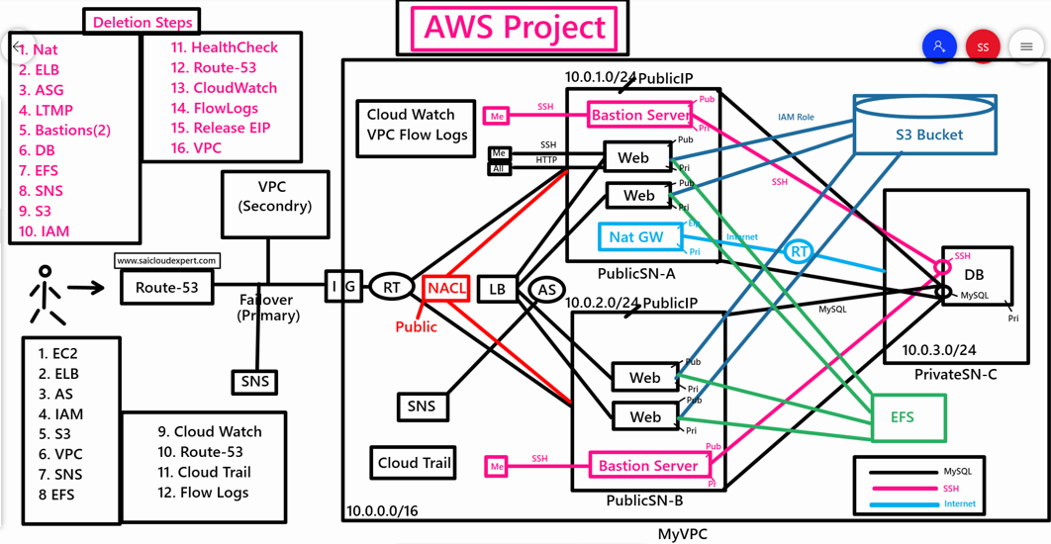

**Project Overview**  
This project is a scalable, secure, and highly available web application hosted on AWS, designed to serve users over the internet. It leverages a variety of AWS services to ensure robust performance, security, and fault tolerance. The architecture includes compute resources, networking, storage, database, monitoring, and security components, all orchestrated within a Virtual Private Cloud (VPC).

**Key Components and Their Roles**

1. **VPC (MyVPC)**
   * The application is deployed within a custom Virtual Private Cloud (MyVPC), which provides an isolated network environment for security and control.
   * The VPC is divided into public and private subnets (PublicSN-A, PublicSN-B, PrivateSN) across multiple Availability Zones (AZs) to ensure high availability and fault tolerance.
2. **Compute Resources**
   * **EC2 Instances (Web and Bastion Servers):**
     + **Web Servers:** Hosted in private subnets, these EC2 instances run the application logic, serving dynamic content to users. They are placed in private subnets for security, accessible only through the load balancer.
     + **Bastion Server:** A secure EC2 instance in the public subnet, used for SSH access to manage instances in private subnets. It acts as a gateway for administrative tasks, enhancing security by limiting direct access to private resources.
   * **IAM Role:** Attached to EC2 instances to grant them secure, controlled access to other AWS services (e.g., S3, RDS) without hardcoding credentials.
3. **Load Balancing (ELB)**
   * An Elastic Load Balancer (ELB) is used to distribute incoming HTTPS traffic across multiple web server instances in different AZs. This ensures high availability, scalability, and fault tolerance by routing traffic to healthy instances only.
   * **HealthCheck:** Configured on the ELB to monitor the health of EC2 instances, ensuring traffic is only sent to operational servers.
4. **Networking**
   * **Route Tables (RT) and Network ACLs (NACL):**
     + Route Tables define how traffic is routed within the VPC, directing traffic between subnets, the internet gateway, and the NAT Gateway.
     + NACLs provide stateless firewall rules at the subnet level to control inbound and outbound traffic, adding an extra layer of security.
   * **NAT Gateway (NatGW):** Deployed in the public subnet, it allows instances in private subnets to access the internet (e.g., for software updates) while preventing inbound internet traffic to those instances.
   * **Route 53:** Used for DNS management, routing user requests to the ELB or other endpoints. It may also support failover configurations (Primary/Secondary) for high availability.
5. **Database (MySQL/RDS)**
   * A MySQL database, hosted on Amazon RDS, stores the application’s data. It’s deployed in private subnets for security, with multi-AZ replication (Primary and Secondary) to ensure high availability and failover in case of an AZ failure.
   * The database is accessible only to the web servers, with access controlled via security groups and IAM.
6. **Storage (S3 Bucket and EFS)**
   * **S3 Bucket:** Used for storing static assets (e.g., images, scripts) or backups. It provides scalable, durable storage accessible to the application via IAM roles.
   * **Elastic File System (EFS):** A shared file system for EC2 instances, allowing multiple web servers to access common files (e.g., application code or logs) across AZs.
7. **Security (IAM, Security Groups, SSH, HTTPS)**
   * **IAM:** Manages permissions for AWS resources. IAM roles are assigned to EC2 instances, and policies ensure least-privilege access.
   * **Security Groups:** Act as instance-level firewalls, controlling traffic to EC2 instances, ELB, and RDS. For example, the ELB allows HTTPS (port 443) from the internet, while web servers allow traffic only from the ELB.
   * **SSH:** Restricted to the Bastion Server, allowing secure administrative access to private instances.
   * **HTTPS:** Ensures secure communication between users and the application via SSL/TLS certificates on the ELB.
8. **Monitoring and Logging**
   * **CloudWatch:** Monitors application performance (e.g., CPU, memory, ELB metrics) and triggers alarms for anomalies. It also collects logs from EC2 instances and other services.
   * **VPC Flow Logs:** Capture network traffic metadata for security and troubleshooting, helping identify unauthorized access or unusual activity.
   * **CloudTrail:** Logs API calls across AWS services, providing an audit trail for security and compliance.
9. **Notifications (SNS)**
   * Simple Notification Service (SNS) sends alerts (e.g., via email or SMS) for events like health check failures, scaling events, or security incidents, enabling proactive monitoring.
10. **High Availability and Failover**
    * The architecture spans multiple AZs (PublicSN-A, PublicSN-B, PrivateSN) to ensure redundancy.
    * **Failover:** Route 53 and RDS multi-AZ configurations provide failover mechanisms to switch to secondary resources in case of failures.
    * **Primary/Secondary:** Refers to database or application-level redundancy to maintain uptime.

**Architecture Workflow**

1. Users access the application via a domain managed by Route 53, which directs traffic to the ELB.
2. The ELB routes HTTPS requests to healthy EC2 web servers in private subnets across multiple AZs.
3. Web servers process requests, interacting with the MySQL RDS database for dynamic data and S3/EFS for static or shared files.
4. The NAT Gateway enables private instances to access the internet for updates, while the Bastion Server allows secure administrative access via SSH.
5. CloudWatch, VPC Flow Logs, and CloudTrail monitor the system, with SNS sending alerts for critical events.
6. Security is enforced through IAM roles, security groups, and NACLs, ensuring only authorized access.

**Deletion Steps (Safely Decommissioning the Infrastructure)**  
When asked about deletion steps in an interview, this shows your understanding of resource cleanup to avoid unnecessary costs and ensure security. A structured approach includes:

1. **Backup Critical Data:** Export data from RDS and S3 to a secure location (e.g., another S3 bucket).
2. **Stop Running Resources:** Terminate EC2 instances (web and bastion servers) and stop RDS instances.
3. **Delete Application Resources:**
   * Remove the ELB and associated health checks.
   * Delete RDS instances (after confirming backups).
   * Delete S3 buckets and EFS file systems (after verifying data is no longer needed).
4. **Remove Networking Components:**
   * Delete the NAT Gateway and detach the internet gateway.
   * Remove route table associations and NACL rules.
   * Delete subnets (PublicSN-A, PublicSN-B, PrivateSN) and the VPC (MyVPC).
5. **Clean Up Security and Monitoring:**
   * Delete IAM roles and policies.
   * Disable CloudWatch alarms, VPC Flow Logs, and CloudTrail trails.
   * Remove SNS topics and subscriptions.
6. **Verify Deletion:** Use AWS Console or CLI to confirm all resources are removed to avoid residual charges.

**Why This Architecture?**

* **Scalability:** ELB and EC2 auto-scaling handle traffic spikes, while S3 and EFS provide scalable storage.
* **Security:** Private subnets, IAM roles, security groups, and NACLs ensure a secure environment.
* **High Availability:** Multi-AZ deployment and failover mechanisms minimize downtime.
* **Cost Efficiency:** Pay-as-you-go AWS services allow cost optimization, with cleanup steps to avoid unnecessary charges.
* **Monitoring:** CloudWatch, CloudTrail, and SNS enable proactive management and auditing.

**Challenges and Solutions**

* **Challenge:** Ensuring secure access to private instances.
  + **Solution:** Use a Bastion Server and restrict SSH access via security groups.
* **Challenge:** Database failover without downtime.
  + **Solution:** RDS multi-AZ with automatic failover and Route 53 for DNS failover.
* **Challenge:** Cost management during development.
  + **Solution:** Use AWS Budgets and carefully delete unused resources during cleanup.

**Conclusion**  
This AWS-based architecture demonstrates a secure, scalable, and highly available web application setup, leveraging best practices for cloud deployment. My role in this project (assuming a typical scenario) involved designing the VPC, configuring the ELB, EC2, and RDS, setting up security with IAM and security groups, and ensuring monitoring with CloudWatch and CloudTrail. The deletion steps reflect my understanding of resource management and cost control.